**UNDERSTAND THE WORLD OF BLOCKCHAIN**



Bitcoin takes a lot of electricity to secure their network.

Mining a new coin takes a lot of computing power because of Proof of Work algorithm.

**PROOF OF WORK**



* It is a concept which is used to make consensus between various nodes in a network.
* It is also used to secure the blockchain.
* It requires a lot of computation power because the miners compete with each other to find next **HASH** for the coin.
* It works by allowing **all nodes to solve a cryptographic puzzle** to find the next hash. The one who finds it first gets the mining reward.
* **Disadvantage of above technique** is miners are building larger and larger mining firm like below

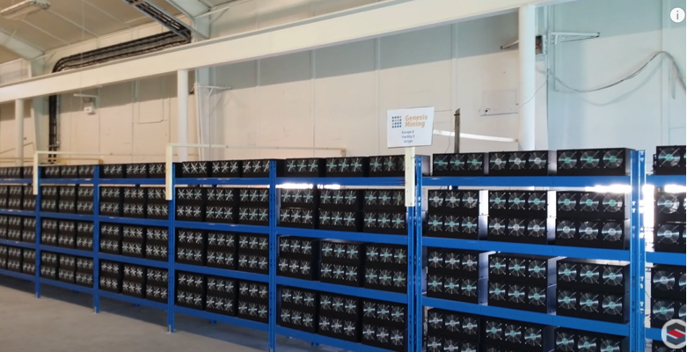

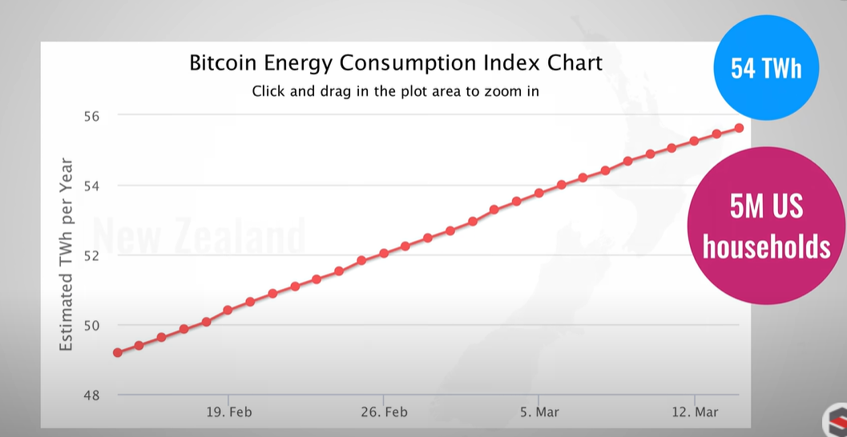

**Bitcoin miners uses 54TWh of electricity enough to power newzealand and hungry.**

**POW gives more reward to people having more equipment and power. The higher your hash rates are higher you are having chance to find next block and thus get more rewards.**

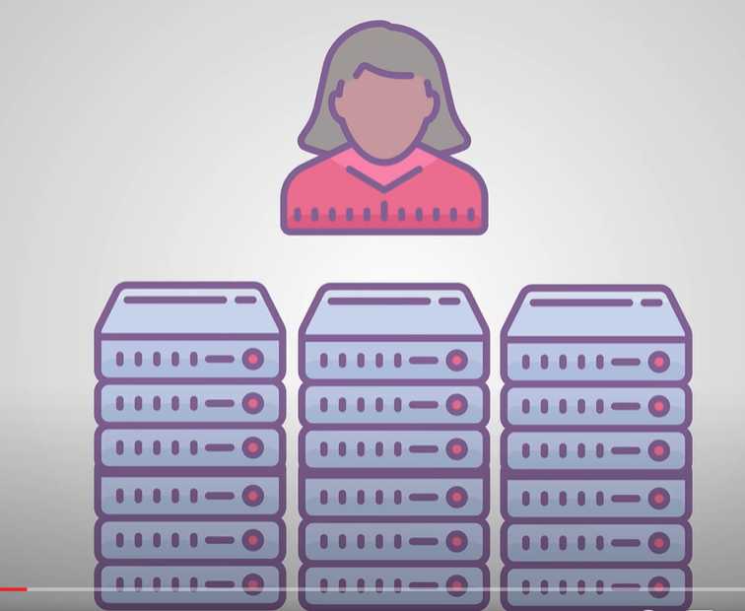

**MINING POOL**

To increase the chances some miners come together to combine their hashing power which is called mining pool. They share their rewards as well.

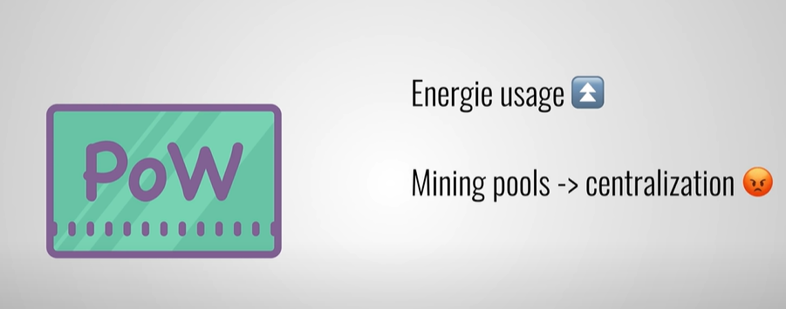

**So POW is using more energy as well as its becoming centralized due to some miners coming together in mining pool.**

**HENCE TO SOLVE THESE ISSUES IN 2011 discovered PROOF OF STAKE**

**PROOF OF STAKE**

The main idea behind this is letting everyone compete against each other is wasteful instead POS does a election and randomly choose one node as a validator to validate next block.



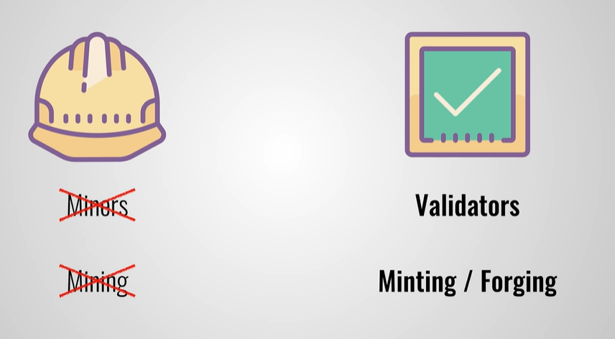

Validators are not chosen randomly rather they have to give pay a certain amount to stake (as security deposit) in the coin to become the validator.

More the stake more is the chance to be selected as validator.

**POS**

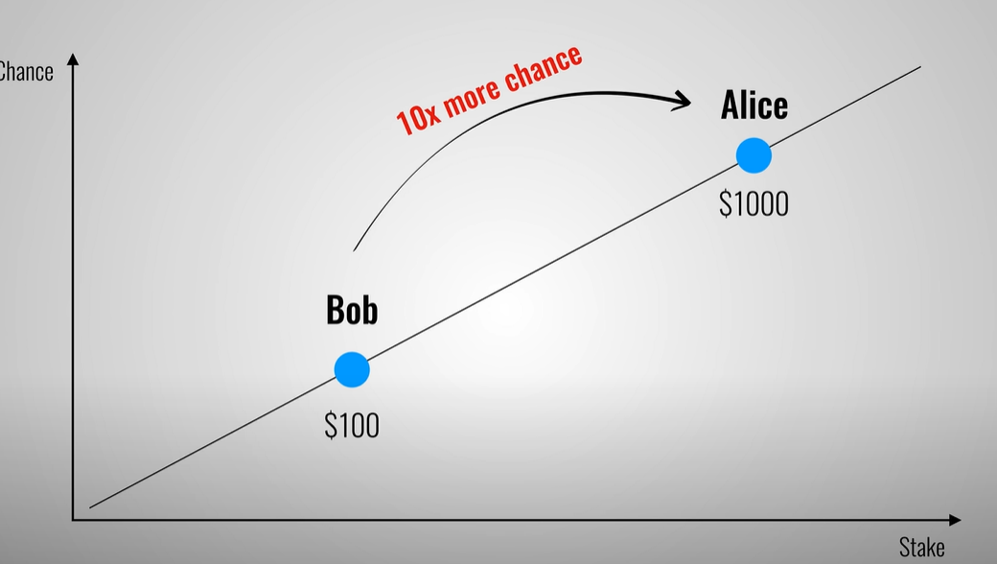

**Linear curve**

**It is not so fair but it is more fair the POW**

**POW**

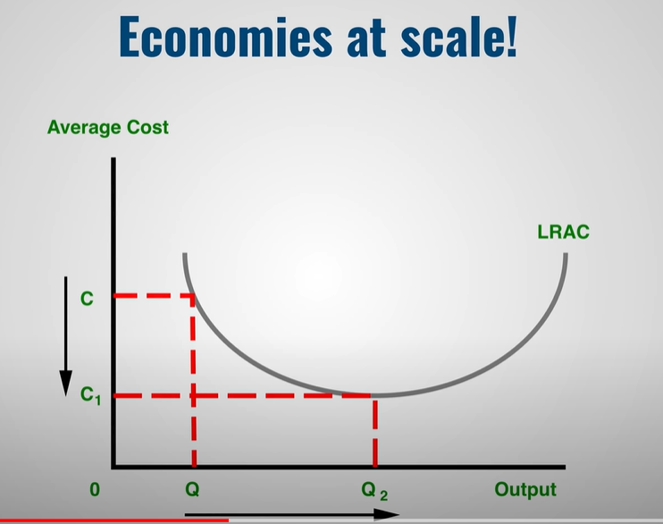

Validators will loose part of their stake if the node is found to be fraudulent. The more the stake of the validator the better they do their job with the fear of losing their stake.



If a node stops being a validator his stake as well as fee is returned after a certain period of time.



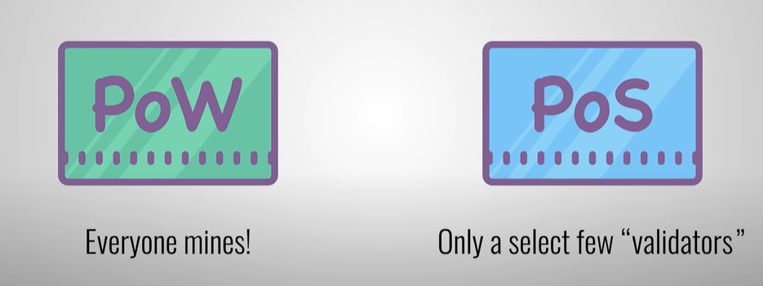

**Hence POS uses considerably less energy than POW cause everyone is not mining.**

POS is more decentralized than POW cause in POW we have mining pool hence some miners come together and centralized the mining process and may do fraudulent. They can start approving fraudulent transactions.

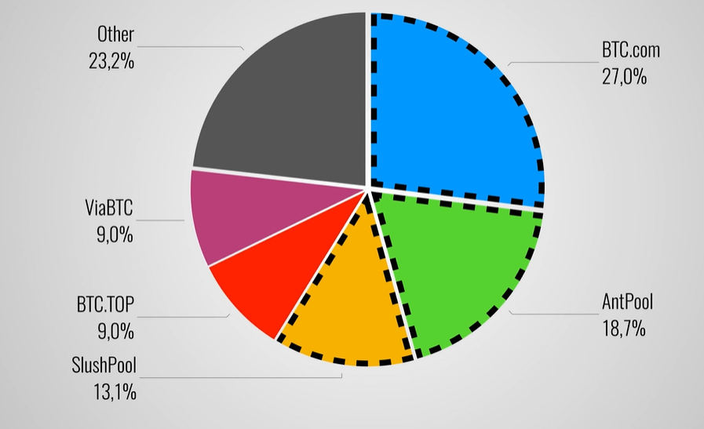

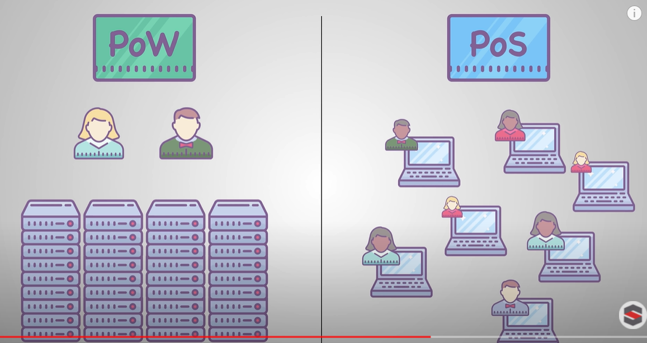

**DISADVANTAGE OF POW**

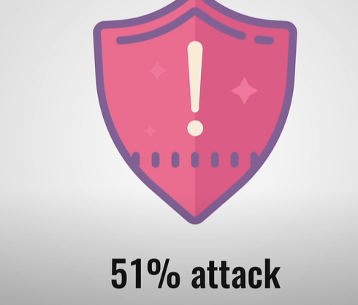

**POS makes 51% attack impractical**

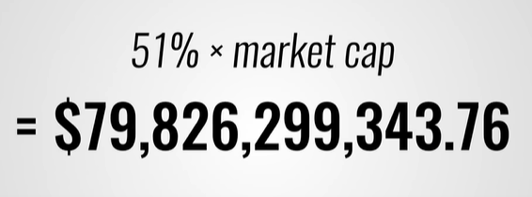

**DISADVANTAGE OF POS**

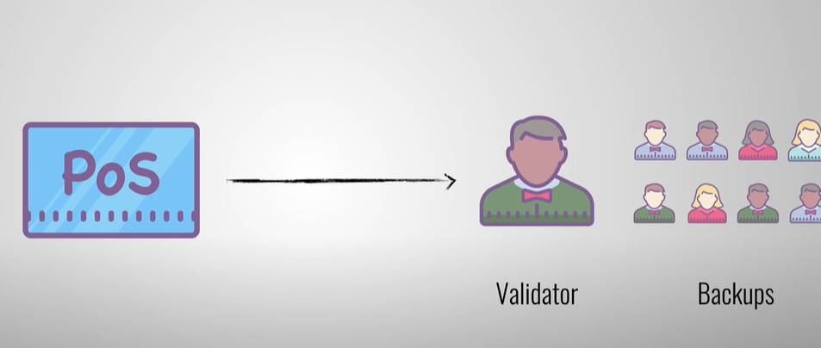

IF validator refuses to do the forging then we have to select backup validator.

Validator are selected based on stake and give more benefit to rich people.